William Williams
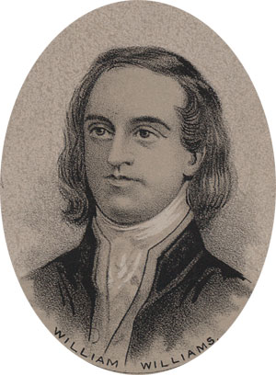
Birth: April 18, 1731 (Lebanon, CT)
Death: Aug. 2, 1811 (Lebanon, CT)
Marriage: Mary Trumbull (Feb. 14, 1771)
(daughter of Jonathan Trumbull)
Birth: July 16, 1745 (Lebanon, CT)
Death: Feb, 1831 (Lebanon, CT)
Children:
Solomon: (1/2/1772- 1810)
Faith: (9/15/1774 - )
William Trumbull: (3/2/1777 - )

- Graduate of Harvard college
- Signer of the Declaration of Independence
- Founder of Williams college

http://www.thedeclarationofindependence.org/WilliamWilliams.com/

http://www.ushistory.org/declaration/signers/williams.htm

The Lives of the Signers of the Declaration of Independence
By Rev. Charles A Goodrich - R.G. H. Huntington – Hartford 1842
(Page 174)
(Page 179)

