Dr. Matthew Thronton
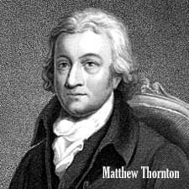
Birth: 1714 (Ireland)
Death: June 24, 1803 (Newburyport, MA)
Marriage: Hannah Jack (abt. 1760)
Birth: 1742 (Chester, NH)
Death: Dec. 5, 1786 (-)
Children: -
James: (12/20/1763 – 7/3/18170
Andrew: (1766 – 4/22/1787)
Mary: (1768 – 5/28/1845)
Matthew: (1770 – 12/5/1804)
Hannah: (7/25/1774 – 5/18/1846)

- Medical Doctor
- Signer of the Declaration of Independence
- Revolutionary War, colonel NH militia

http://www.nh.searchroots.com/HillsboroughCo/Merrimack/familytrees3.html#Thornton

http://colonialhall.com/thornton/thornton.php

The Lives of the Signers of the Declaration of Independence
By Rev. Charles A Goodrich - R.G. H. Huntington – Hartford 1842

(Page 145) Speech given as president of the NH provincial convention June 2, 1775
“Duty to God, to ourselves, to posterity, enforced by cries of slaughtered innocents, have urged us to take up arms in our defense……We would, therefore, recommend to the colony at large, to cultivate that Christian union, harmony, and tender affection, which is the only foundation upon which our invaluable privileges can rest with any security, or our public measures be pursued with the least prospect of success.”
(Page 146) (continuation of speech)
In a word, we seriously and earnestly recommend the practice of that pure and undefiled religion which embalmed the memory of our pious ancestors, as that alone upon which we can build a solid hope and confidence in the Divine protection and favor, without whose blessing all the measures of safety we have or can propose will end in our shame and disappointment.
(Page 147)
Note:
Try and find copy of this work.
(Page 148)

