Charles Thomson
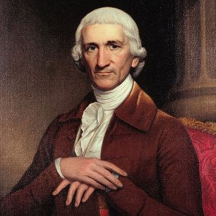
Birth: November 29, 1729(Maghera, Ireland)
Death: August 16, 1824 (Lower Merion, PA)
Marriage: Hannah Harrison (Sept 1, 1774)
(sister of Benjamin Harrison)
Birth: Dec. 23, 1728 (Philadelphia Co. PA)
Death: Sept 6, 1897 (-)
Children:

- 1740 emigrated to America
- 1756 adopted as a member of the Delaware Indians
(Called him their tongue “man of truth”)
- 1774-89 Secretary of the Continental Congress
- Their home at Fair Hill, burned by British General Howe
- Designer of the Great Seal of the U.S.
- Signed the Original Draft of the Declaration of Independence
(John Hancock the only other person to sign)
- 1789-1808 work on the fist translation of the Bible from Greek

http://www.rebelswithavision.com/CharlesThomson.com/

http://womenhistory.blogspot.com/2008/10/hannah-harrison-thomson.html

http://en.wikipedia.org/wiki/Charles_Thomson

http://www.wallbuilders.com/LIBissuesArticles.asp?id=8755
The Founding Fathers on Jesus, Christianity and the Bible

I am a Christian. I believe only in the Scriptures, and in Jesus Christ my Savior.
(The Autobiography of Benjamin Rush; His “Travels Through Life” together with his Commonplace Book for 1789-1813, George W. Carter, editor (New Jersey: Princeton University Press, 1948), p. 294, October 2, 1810.)

Hannah (Harrison) Thompson
http://books.google.com/books?id=jEUVAAAAYAAJ&pg=PA192&lpg=PA192&dq=%22Charles+Thomson%22+%22Hannah+Harrison%22&source=bl&ots=CR_7YBpemS&sig=COFEM5lUW5gfD8fabKd7j2a3b70&hl=en&ei=2CX7SazEO6TyswOAwLzKAQ&sa=X&oi=book_result&ct=result&resnum=9
Assisted her husband in duties as secretary of congress
“During the occupancy, when her home near Fair Hill, previously occupied by them, was burned by order of General Howe, and the enemy despoiled whatever was in their reach, she thought only of the suffering of those who were holding the British at bay, prayerfully believing in the Lord of Hosts, and that the victory of battle was not always to the strong and mighty.”

