William Howard Taft
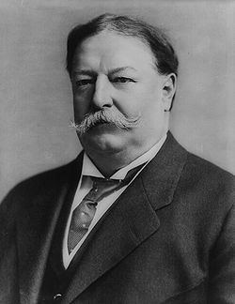
Birth: Sep 15, 1857 (Cincinnati, OH)
Death: Mar 8, 1930 (Washington, DC)
Marriage: Helen Herron (June 19, 1886)
Birth: Jun. 2, 1861(Cincinnati, OH)
Death: May 22, 1943 (Washington DC)
Children:
Robert: (-)
Helen: (-)
Charles Phelps: (-)

- Governor of Philippines (1901-1903)
- Secretary of War (1904-1908)
- Provisional Governor of Cuba (1906)
- 27th President of U.S. (1909-1913)
- Chief Justice U.S. (1921-1930)

http://en.wikipedia.org/wiki/William_Howard_Taft

http://hockingcountyndp.org/History.dsp
No man can study the movement of modern civilization from an impartial standpoint and not realize that Christianity and the spread of Christianity are the basis of hope of modern civilization in the growth of popular self-government. The spirit of Christianity is pure democracy. It is equality of man before God—the equality of man before the law, which is, as I understand it, the most God-like manifestation that man has been able to make.
(William Howard Taft, in an address to a missionary gathering in 1908)

http://www.wallbuilders.com/LIBissuesArticles.asp?id=4079
This is the text of the November 15, 1909 William Howard Taft national Thanksgiving Day Proclamation.

The season of the year has returned when, in accordance with the reverent custom established by our forefathers, the people of the United States are wont to meet in their usual places of worship on a day of thanksgiving appointed by the Civil Magistrate to return thanks to God for the great mercies and benefits which they have enjoyed.

During this past year we have been highly blest. No great calamities of flood or tempest or epidemic sickness have befallen us. We have lived in quietness, undisturbed by wars or the rumors of wars. Peace and the plenty of bounteous crops and of great industrial production animate a cheerful and resolute people to all the renewed energies of beneficent industry and material and moral progress. It is altogether fitting that we should humbly and gratefully acknowledge the divine source of these blessings.

Therefore I appoint Thursday, the twenty-fifth day of November, as a day of general thanksgiving, and I call upon the people on that day, laying aside their usual vocations, to repair to their churches and unite in appropriate services of praise and thanks to Almighty God.

In Witness Whereof I have hereunto set my hand and caused the seal of the United States to be affixed.

Done at the City of Washington this fifteenth day of November, in the year of our Lord one thousand nine hundred and nine and of the independence of the United States the one hundred and thirty-fourth.
Wm H Taft

