Caleb Strong
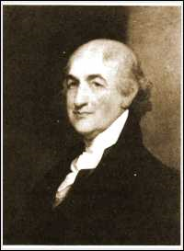
Birth: Jan 9, 1745 (Northhampton, MA)
Death: Nov. 7, 1819 (Northhampton, MA)
Marriage: Sarah _____ (-)
Birth: - (-)
Death: 1817 (-)
Children: (they had nine children)

- Delegate to Constitutional Convention
- Ratifier of the Constitution
- U.S. Senator from MA (1789 – 1796)
- Governor of MA (1800 – 1807 & 1812 – 1816)

http://en.wikipedia.org/wiki/Caleb_Strong

http://bioguide.congress.gov/scripts/biodisplay.pl?index=S001009

http://www.archives.gov/exhibits/charters/constitution_founding_fathers_massachusetts.html

http://www.wallbuilders.com/LIBissuesArticles.asp?id=8755
The Founding Fathers on Jesus, Christianity and the Bible

He called on the State of Massachusetts to pray that . . . all nations may know and be obedient to that grace and truth which came by Jesus Christ.
(Caleb Strong, Governor of Massachusetts, Proclamation for a Day of Fasting, Prayer and Humiliation, February 13, 1813, from a proclamation in Wallbuilders possession, Shaw #29090.)

