Joseph Story
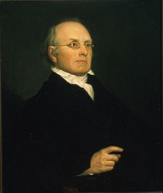
Birth: Sept 18, 1779 (Marblehead, MA)
Death: Sept 10, 1845 (Cambridge, MA)
Marriage: Mary Lynde Fitch Oliver (Dec. 9 1804)
Birth: 1781 (-)
Death: June 1805 (-)
Children:

Marriage: Sarah Waldo Wetmore (Aug. 1808)
Birth: 1784 (-)
Death: 1855 (-)
Children: (7 children only 2 survived to adulthood)
Mary: (-)
William Wetmore: (2/12/1819 -10/7/1895)

- Graduate Harvard class of 1798
- U.S. Congressman from MA (1808-1809)
- U.S. Supreme Court Justice (1811-1845
- Father of American Jurisprudence

http://en.wikipedia.org/wiki/Joseph_Story

http://www.wallbuilders.com/LIBissuesArticles.asp?id=8755
The Founding Fathers on Jesus, Christianity and the Bible

One of the beautiful boasts of our municipal jurisprudence is that Christianity is a part of the Common Law. There never has been a period in which the Common Law did not recognize Christianity as lying at its foundations.
(Joseph Story, Life and Letters of Joseph Story, William W. Story, editor (Boston: Charles C. Little and James Brown, 1851), Vol. II, p. 8.)
I verily believe that Christianity is necessary to support a civil society and shall ever attend to its institutions and acknowledge its precepts as the pure and natural sources of private and social happiness.
(Joseph Story, Life and Letters of Joseph Story, William W. Story, editor (Boston: Charles C. Little and James Brown, 1851), Vol. I, p. 92, March 24, 1801.)

