Thomas Stone
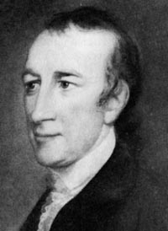
Birth: 1743 (Charles Co. MD)
Death: October 5, 1787 (MD)
Marriage: Margaret Stone (1768)
Birth: 1751 (-)
Death: 1787 (-)
Children:
Margaret: (1771-1809)
Mildred: (1773-1837)
Fredrik: (1774-1793)

- Signer of the Declaration of Independence
- Delegate to the Constitutional Convention

http://en.wikipedia.org/wiki/Thomas_Stone

http://colonialhall.com/stone/stone.php

http://www.wallbuilders.com/LIBissuesArticles.asp?id=8755
The Founding Fathers on Jesus, Christianity and the Bible

Shun all giddy, loose, and wicked company; they will corrupt and lead you into vice and bring you to ruin. Seek the company of sober, virtuous and good people… which will lead [you] to solid happiness.
(John Sanderson, Biography of the Signers to the Declaration of Independence (Philadelphia: R. W. Pomeroy, 1824), Vol. IX, p. 333, Thomas Stone to his son, October 1787.)

The Lives of the Signers of the Declaration of Independence
By Rev. Charles A Goodrich - R.G. H. Huntington – Hartford 1842
(Page 357)

