Richard Dobbs Spaight Sr.
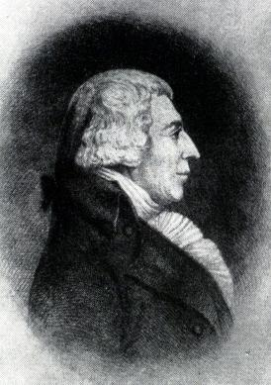
Birth: March 25, 1758 (New Bern, NC)
Death: September 6, 1802 (New Bern, NC)
(struck down in a duel)
Marriage: Mary Leach (March 24, 1788)
Birth: -(-)
Death: - (-)
Children: (3)
Richard Dobbs Jr. (-)

- Signer of the Constitution
- Lt Colonel artillery regiment Revolutionary Army
- 1792-1795 Governor NC
- 1798-1801 U.S. House of Representative from NC

http://en.wikipedia.org/wiki/Richard_Dobbs_Spaight

http://www.history.army.mil/books/RevWar/ss/spaight.htm

http://www.nps.gov/history/history/online_books/constitution/bio36.htm

http://books.google.com/books?id=8zcjYPZxPV0C&pg=PA278&lpg=PA278&dq=%22richard+dobbs+spaight%22+%22mary+leach%22&source=bl&ots=7-aB0_sgl7&sig=UIz7obZKqLJM1xoXPoQUE3agPDA&hl=en&ei=Rzf7SdXsHaHYswPHv8zeAQ&sa=X&oi=book_result&ct=result&resnum=2#PPA276,M1
(page 277)

http://www.wallbuilders.com/LIBissuesArticles.asp?id=121
The Founders and Public Religious Expressions

As to the subject of religion. . . . no power is given to the general government to interfere with it at all. . . . No sect is preferred to another. Every man has a right to worship the Supreme Being in the manner he thinks proper.
(As to the subject of religion. . . . no power is given to the general government to interfere with it at all. . . . No sect is preferred to another. Every man has a right to worship the Supreme Being in the manner he thinks proper.
(The Debates in the Several State Conventions on the Adoption of the Federal Constitution, Jonathan Elliot, editor (Washington, D. C.: Jonathan Elliot, 1836), Vol. IV, p. 208, Richard Dobbs Spaight, July 30, 1788.)

