James Smith
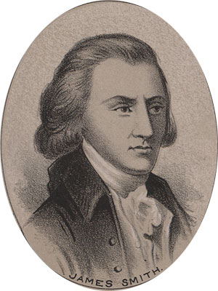
Birth: Sept 17, 1719 (Dublin, Ireland)
Death: July 11, 1806 (-)
Marriage: Eleanor Armor (1760)
Birth: 1729(-)
Death: July 13, 1818 (-)
Children: 3 sons, 2 daughters
(1 son, 1 daughter survived him)
James Jr. ( - 1806)
Mary: (4/20/1763 – 4/20/1840)
Elizabeth: ( - 9/6/1793)

- Signer of the Declaration of Independence
- Continental Congress (1776 – 1777)

http://www.ushistory.org/declaration/signers/smith.htm

http://www.dsdi1776.com/Signers/James%20Smith.html

http://en.wikipedia.org/wiki/James_Smith_(delegate)

The Lives of the Signers of the Declaration of Independence
By Rev. Charles A Goodrich - R.G. H. Huntington – Hartford 1842
(Page 296)

