Roger Sherman
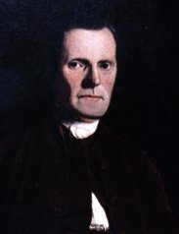
Birth: Apr 19, 1721 (Newton, MA)
Death: July 23, 1793 (New Haven, CT)
Marriage: Elizabeth Hartwell (Nov 17, 1749)
Birth: abt 1726(-)
Death: Oct 1760 (-)
Children:
John: (-)
William: (-)
Isaac: (6/22/1753-)
Chloe: (-)
Oliver: (-)
Chloe: (-)
Elizabeth: (-)
Marriage: Rebecca Prescott (May 12, 1763)
Birth: - (-)
Death: - (-)
Children:
Rebecca: (-)
Elizabeth: (-)
Mehitable: (-)
Mehitable: (-)
Oliver: (-)
Martha: (-)
Sarah: (-)
Roger: (July 16, 1768-Mar 5, 1856)

- Admitted to Bar CT (1754)
- General Assembly representing New Milford CT (1755-1758 & 1760-1761)
- Commissary for CT troops (1759)
- Judge for Superior Court of CT (1766-1789)
- Continental Congress (1774-1781 & 1783-1784)
- Distinguished member of the Constitutional Convention (1787)
- U.S. Senate (1791-1793)
- Framer of the Bill of Rights
- Only person to sign all four original papers of the U.S.
Articles of Association
Declaration of Independence
Articles of Confederation
The Constitution

http://www.ushistory.org/declaration/signers/sherman.htm

http://files.usgwarchives.net/ma/middlesex/towns/watertown/watertown360-643.bak

http://www.genealogy.com/users/d/e/l/Sandra-Deloyd/FILE/0001text.txt

http://wc.rootsweb.ancestry.com/cgi-bin/igm.cgi?op=GET&db=lisareal&id=I1174

http://www.wallbuilders.com/LIBissuesArticles.asp?id=8755
The Founding Fathers on Jesus, Christianity and the Bible

I believe that there is one only liv¬ing and true God, existing in three persons, the Father, the Son, and the Holy Ghost, the same in substance, equal in power and glory. That the Scriptures of the Old and New Tes¬taments are a revelation from God, and a complete rule to direct us how we may glorify and enjoy Him. . . . That He made man at first perfectly holy; that the first man sinned, and as he was the public head of his posterity, they all became sinners in consequence of his first transgres¬sion, are wholly indisposed to that which is good and inclined to evil, and on account of sin are liable to all the miseries of this life, to death, and to the pains of hell forever. I believe that God . . . did send His own Son to become man, die in the room and stead of sinners, and thus to lay a foundation for the offer of pardon and salvation to all mankind, so as all may be saved who are willing to accept the Gospel offer. . . . I believe a visible church to be a congregation of those who make a credible profession of their faith in Christ, and obedi¬ence to Him, joined by the bond of the covenant. . . . I believe that the sacraments of the New Testament are baptism and the Lord’s Supper. . . . I believe that the souls of believers are at their death made perfectly holy, and immediately taken to glory: that at the end of this world there will be a resurrec¬tion of the dead, and a final judgment of all mankind, when the righteous shall be publicly acquitted by Christ the Judge and admitted to everlasting life and glory, and the wicked be sentenced to everlasting punishment.
(Lewis Henry Boutell, The Life of Roger Sherman (Chicago: A. C. McClurg and Company, 1896), pp. 271-273. http://www.wallbuilders.com/LIBissuesArticles.asp?id=78)
God commands all men everywhere to repent. He also commands them to believe on the Lord Jesus Christ, and has assured us that all who do repent and believe shall be saved… [G]od… has absolutely promised to bestow them on all these who are willing to accept them on the terms of the Gospel – that is, in a way of free grace through the atonement. “Ask and ye shall receive [John 16:24]. Whosoever will, let him come and take of the waters of life freely [Revelation 22:17]. Him that cometh unto me I will in no wise cast out” [John 6:37].
(Correspondence Between Roger Sherman and Samuel Hopkins (Worcester, MA: Charles Hamilton, 1889), p. 9, from Roger Sherman to Samuel Hopkins, June 28, 1790.)

[I]t is the duty of all to acknowledge that the Divine Law which requires us to love God with all our heart and our neighbor as ourselves, on pain of eternal damnation, is Holy, just, and good. . . . The revealed law of God is the rule of our duty.
(Correspondence Between Roger Sherman and Samuel Hopkins (Worcester, MA: Charles Hamilton, 1889), p. 10, from Roger Sherman to Samuel Hopkins, June 28, 1790.)

True Christians are assured that no temptation (or trial) shall happen to them but what they shall be enabled to bear; and that the grace of Christ shall be sufficient for them.
(Correspondence Between Roger Sherman and Samuel Hopkins (Worcester, MA: Charles Hamilton, 1889), p. 26, from Roger Sherman to Samuel Hopkins, October, 1790.)

“The volume which he consulted more than any other was the Bible. It was his custom, at the commencement of every session of Congress, to purchase a copy of the Scriptures, to peruse it daily, and to present it to one of his children on his return.”
(The Globe (Washington DC newspaper), August 15, 1837, p. 1.)

The Lives of the Signers of the Declaration of Independence
By Rev. Charles A Goodrich - R.G. H. Huntington – Hartford 1842
(Page 159)
(Page 166-167)
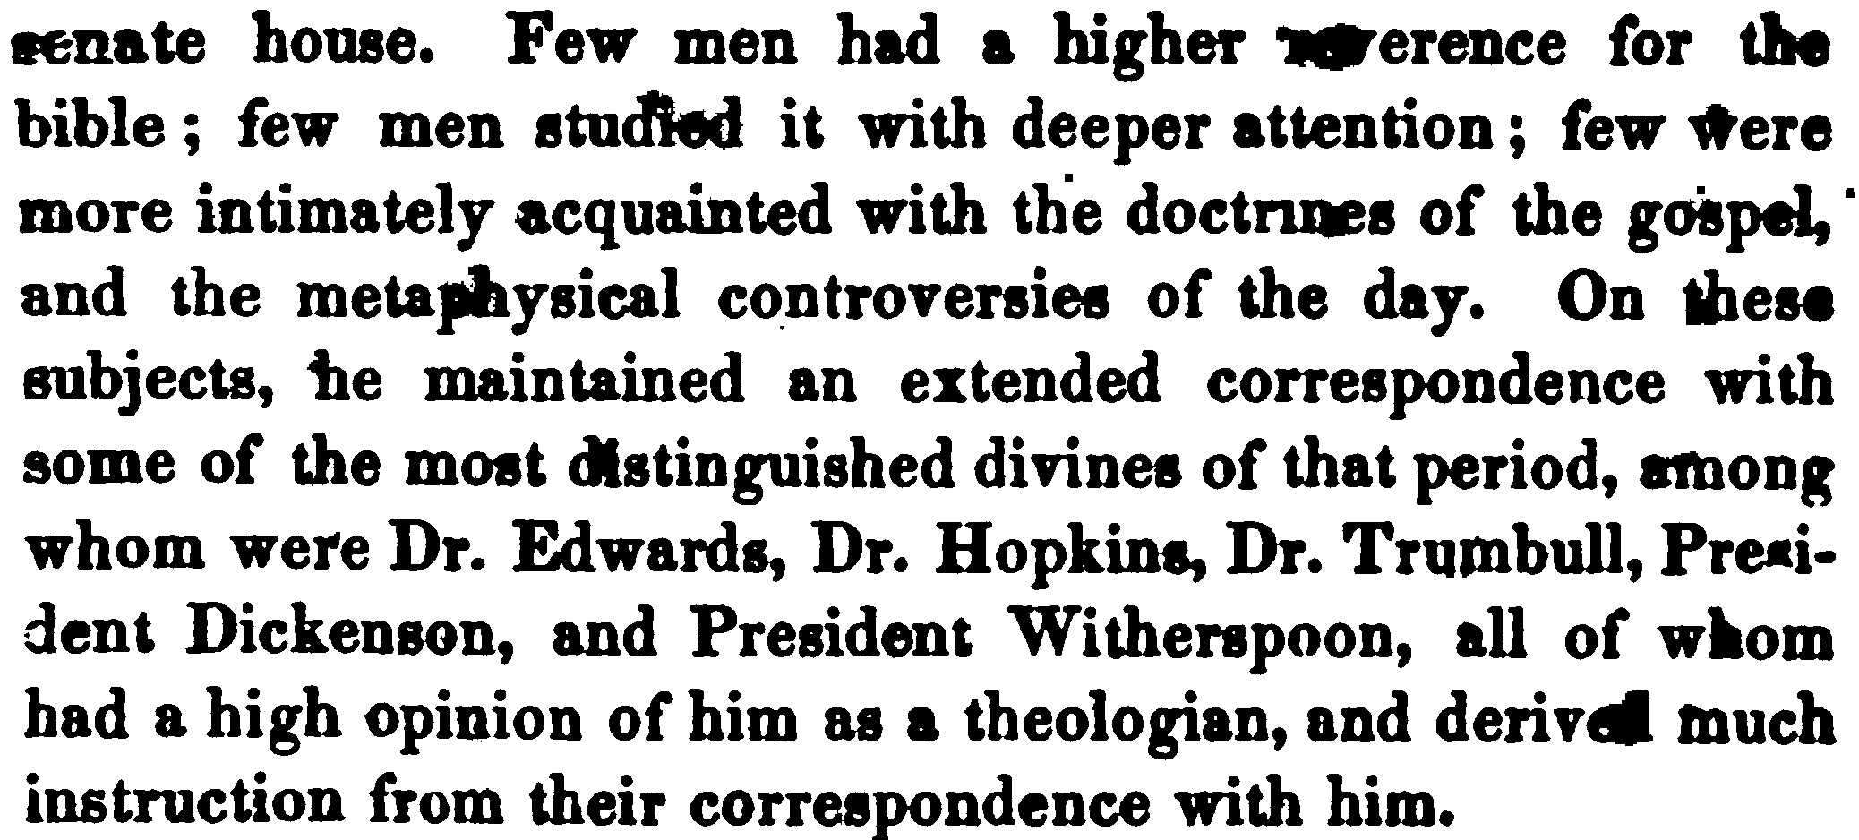
(Pages 167-168) Contains a story about a family Bible study

