Dr. Benjamin Rush
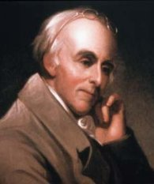
Birth: Dec 12, 1745 (Byberry Twp, near Philadelphia, PA)
Death: Apr 19, 1813 (-)
Marriage: Julia Stockton (Jan 2, 1776)
(daughter of Richard Stockton)
Birth: March 2, 1759(-)
Death: July 7, 1846 (-)
Children:
Lt. John B: (July 17, 1777-Aug 9, 1837)
Annie Emily: (Jan 1, 1779-Apr 27, 1850
Richard D: (Aug 29, 1780-July 28, 1859)
Susanna: (Jan 7, 1782-May 20, 1782)
Elizabeth Graeme: (Feb 14, 1783-July 2, 1783)
Mary B: (May 16, 1784-Nov 2, 1849)
Dr. James: (Mar 15, 1786-May 26, 1869)
William: (Nov 8, 1787-Jan 15, 1788)
Benjamin: (July 3, 1789-July 21, 1789)
Benjamin Jr.: (Feb 18, 1791-Dec 17, 1824)
Julia: (Nov 22, 1792-Apr 19, 1860)
Dr. Samuel: (Aug 1, 1795-Nov 24, 1859)
Dr. William: (May 11, 1801-Nov 20, 1864)

- Graduate Princeton College (1760)
- Degree of M.D. from Edinburgh University (1768)
- Signer of the Declaration of Independence (1776)
- Surgeon general of the armies (1777)
- Ratifier of the Constitution
- Treasurer of the U.S. Mint
- Father of public schools under the constitution
- Father of American Medicine
- Father of American Psychiatry
- President of the society for the abolition of slavery

http://www.benjaminrush.com/

http://homepages.rootsweb.ancestry.com/~cousin/html/p471.htm#i1125

http://www.wallbuilders.com/LIBissuesArticles.asp?id=8755
The Founding Fathers on Jesus, Christianity and the Bible

The Gospel of Jesus Christ prescribes the wisest rules for just conduct in every situation of life. Happy they who are enabled to obey them in all situations! . . . My only hope of salvation is in the infinite tran¬scendent love of God manifested to the world by the death of His Son upon the Cross. Noth¬ing but His blood will wash away my sins [Acts 22:16]. I rely exclusively upon it. Come, Lord Jesus! Come quickly! [Revelation 22:20]
(Benjamin Rush, The Autobiography of Benjamin Rush, George W. Corner, editor (Princeton: Princeton University Press, 1948), pp. 165-166.)
I do not believe that the Constitution was the offspring of inspiration, but I am as satisfied that it is as much the work of a Divine Providence as any of the miracles recorded in the Old and New Testament.
(Benjamin Rush, Letters of Benjamin Rush, L. H. Butterfield, editor (Princeton, New Jersey: American Philosophical Society, 1951), Vol. I, p. 475, to Elias Boudinot on July 9, 1788.)

By renouncing the Bible, philosophers swing from their moorings upon all moral subjects… It is the only correct map of the human heart that ever has been published.
(Benjamin Rush, Letters of Benjamin Rush, L. H. Butterfield, editor (Princeton, NJ: Princeton University Press, 1951), Vol. II, p. 936, to John Adams, January 23, 1807.)

[T]he greatest discoveries in science have been made by Christian philosophers and . . . there is the most knowledge in those countries where there is the most Christianity.
(Benjamin Rush, Essays, Literary, Moral and Philosophical (Philadelphia: Thomas and William Bradford, 1806), p. 84, Thoughts upon Female Education.”)

[T]he only means of establishing and perpetuating our republican forms of government is the universal education of our youth in the principles of Christianity by means of the Bible.¹⁰²
(Benjamin Rush, Essays, Literary, Moral & Philosophical (Philadelphia: Thomas & Samuel F. Bradford, 1798), p. 112, “A Defence of the Use of the Bible as a School Book.”)

The great enemy of the salvation of man, in my opinion, never invented a more effective means of limiting Christianity from the world than by persuading mankind that it was improper to read the Bible at schools.
(Benjamin Rush, Letters of Benjamin Rush, L. H. Butterfield, editor (Princeton, NJ: Princeton University Press, 1951), Vol. I, p. 521, to Jeremy Belknap on July 13, 1789.)

[C]hristianity is the only true and perfect religion; and… in proportion as mankind adopt its principles and obey its precepts, they will be wise and happy.
(Benjamin Rush, Essays, Literary, Moral & Philosophical (Philadelphia: Thomas & Samuel F. Bradford, 1798), p. 93, “A Defence of the Use of the Bible as a School Book.” See also Rush, Letters, Vol. I, p. 578, to Jeremy Belknap on March 2, 1791.)

The Bible contains more knowledge necessary to man in his present state than any other book in the world.
(Benjamin Rush, Essays, Literary, Moral & Philosophical (Philadelphia: Thomas & Samuel F. Bradford, 1798), p. 93, “A Defence of the Use of the Bible as a School Book;” see also Rush, Letters, Vol. I, p. 578, to Jeremy Belknap on March 2, 1791.)

The Bible, when not read in schools, is seldom read in any subsequent period of life… [T]he Bible… should be read in our schools in preference to all other books because it contains the greatest portion of that kind of knowledge which is calculated to produce private and public happiness.
(Benjamin Rush, Essays, Literary, Moral & Philosophical (Philadelphia: Thomas & Samuel F. Bradford, 1798), pp. 94, 100, “A Defence of the Use of the Bible as a School Book.”)

http://www.wallbuilders.com/LIBissuesArticles.asp?id=121
The Founders and Public Religious Expressions

Such is my veneration for every religion that reveals the attributes of the Deity, or a future state of rewards and punishments, that I had rather see the opinions of Confucius or Mohamed inculcated upon our youth than see them grow up wholly devoid of a system of religious principles. But the religion I mean to recommend in this place is that of the New Testament. . . . [A]ll its doctrines and precepts are calculated to promote the happiness of society and the safety and well-being of civil government.
(Benjamin Rush, Essays, Literary, Moral and Philosophical (Philadelphia: Thomas and Samuel F. Bradford, 1798), p. 8, “Of the Mode of Education Proper in a Republic.”)

However, while Dr. Rush was outspoken about his personal Christian preferences, he was also gratified with the religious tolerance exercised in America. In fact, in his description of the federal parade in Philadelphia following the adoption of the Constitution, Rush happily declared:
“The rabbi of the Jews locked in the arms of two ministers of the Gospel was a most delightful sight. There could not have been a more happy emblem!”
(Benjamin Rush, Letters of Benjamin Rush, L. H. Butterfield, editor (Princeton: American Philosophical Society, 1951), Vol. I, p. 474, to Elias Boudinot on July 9, 1788.)

http://www.wallbuilders.com/LIBissuesArticles.asp?id=78
The Founders as Christians

My only hope of salvation is in the infinite, transcendent love of God manifested to the world by the death of His Son upon the cross. Nothing but His blood will wash away my sins. I rely exclusively upon it. Come, Lord Jesus! Come quickly!
(Benjamin Rush, The Autobiography of Benjamin Rush, George Corner, editor (Princeton: Princeton University Press for the American Philosophical Society, 1948), p. 166, Travels Through Life, An Account of Sundry Incidents & Events in the Life of Benjamin Rush.)

http://www.biblebelievers.com/Bible_in_schools.html

"It is now several months since I promised to give you my reasons for preferring the Bible as a schoolbook to all other compositions. Before I state my arguments, I shall assume the five following propositions:
1. That Christianity is the only true and perfect religion; and that in proportion as mankind adopts its principles and obeys its precepts they will be wise and happy.
2. That a better knowledge of this religion is to be acquired by reading the Bible than in any other way.
3. That the Bible contains more knowledge necessary to man in his present state than any other book in the world.
4. That knowledge is most durable, and religious instruction most useful, when imparted in early life.
5. That the Bible, when not read in schools, is seldom read in any subsequent period of life.
My arguments in favor of the use of the Bible as a schoolbook are founded.

The Lives of the Signers of the Declaration of Independence
By Rev. Charles A Goodrich - R.G. H. Huntington – Hartford 1842
(Page 248 – the year was 1793)
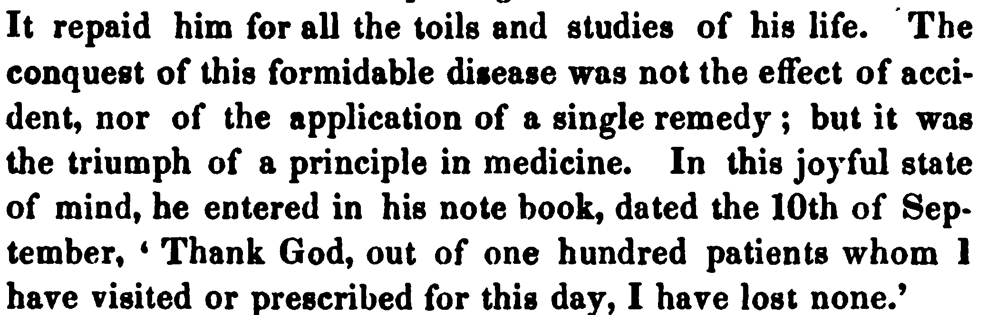
(Page 254-255)
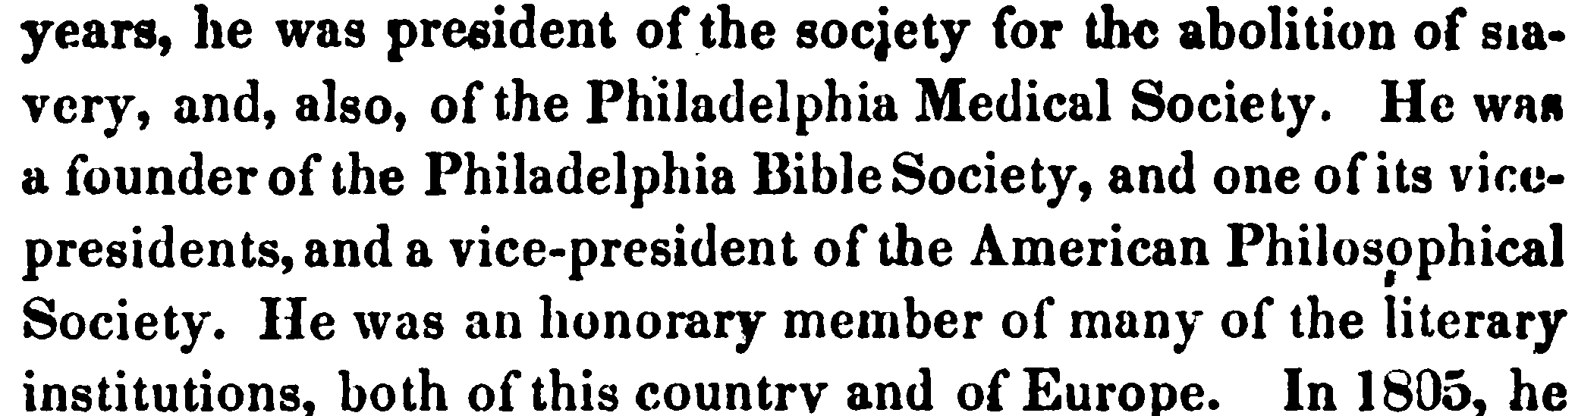
(Page 259 -260)

