George Read
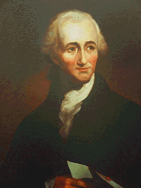
Birth: Sept. 18, 1733 (Cecil Co. MD)
Death: Sept 21, 1798 (New Castle, DE)
Marriage: Gertrude Ross (Jan 11, 1763)
(Sister of George Ross)
(first married to Rev Isaac Till, deceased)
Birth: 1732 (-)
Death: 1802 (-)
Children:
John: (1763 – died young)
George Jr: (1765 - 1836)
William: (1767 - 1826)
John: (1769 - 1854)
Mary: (1770 - 1816)

- Continental Congress (1774 – 1777)
- Signer of the Declaration of Independence
- President of DE (1777 – 1778)
(filling in for captured Thomas McKean)
- U.S. Senate from DE (1789 – 1793)
- Chief Justice of DE (1793 – 1798)

http://en.wikipedia.org/wiki/George_Read_%28signer%29

http://www.ushistory.org/declaration/signers/read.htm

http://www.womenhistoryblog.com/2009/11/gertrude-ross-till-read.html

The Lives of the Signers of the Declaration of Independence
By Rev. Charles A Goodrich - R.G. H. Huntington – Hartford 1842
(Page 321 – year was 1775)
(Page 321)

