Charles Cotesworth Pinckney
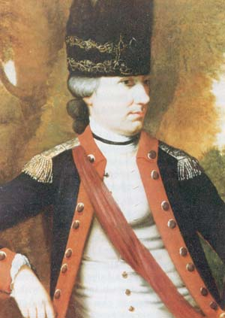
Birth: February 25, 1746 (Charleston, SC)
Death: August 16, 1825 (-)
Marriage: Mary Laurens (-)
(daughter of Henry Laurens)
Birth: -(-)
Death: in child birth, soon after marriage
Children:

- Studied at Royal Military College, Caen, France
- Revolutionary General
- Legislator
- Signer of the Constitution
- 1796-7 U.S. Minister to France

http://www.history.army.mil/books/RevWar/ss/pinckneycc.htm

http://www.wallbuilders.com/LIBissuesArticles.asp?id=8755
The Founding Fathers on Jesus, Christianity and the Bible

To the eternal and only true God be all honor and glory, now and forever. Amen!
(From his last will and testament, attested October 8, 1807.)

