William Paterson
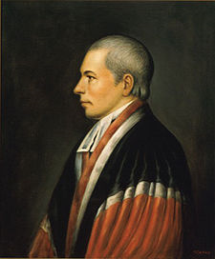
Birth: Dec 24, 1745 (Northern Ireland)
Death: Sep 9, 1806 (-)
Marriage- (-)
Birth: -(-)
Death: - (-)
Children:

- Graduate of Princeton 1763
- Attorney General of NJ (1776-1783)
- Signer of the Constitution
- U.S. Senator (1789-1790)
- Governor of NJ (1790-1793)
- U.S. Supreme Court Justice (1793-1806)

http://en.wikipedia.org/wiki/William_Paterson_%28judge%29

http://www.wallbuilders.com/LIBissuesArticles.asp?id=8755
The Founding Fathers on Jesus, Christianity and the Bible

When the righteous rule, the people rejoice; when the wicked rule, the people groan. [invoking Proverbs 29:2 to instruct a grand jury].
(United States Oracle (Portsmouth, NH), May 24, 1800.)

