William Paca
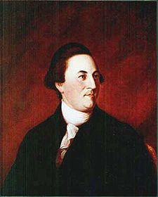
Birth: Oct 31, 1740 (Hartford Co. MD)
Death: Oct 13, 1799 (Queen Anne’s Co. MD)

Marriage: Mary Chew (May 26, 1763)
Birth: 1736 (Anne Arundel Co. MD)
Death: Jan. 15, 1774 (-)
Children: (3, only John survived to adulthood)
John: (3/17/1771 -)

Illegitimate: Free Black Women (no marriage)
Birth: - (-)
Death: - (-)
Children:
Hester: (8/26/1775 -)

Illegitimate: Sarah Joice (no marriage)
Birth: - (-)
Death: - (-)
Children:
Henrietta Maria: (1776 -)

Marriage: Ann Harrison (1777)
Birth: - (-)
Death: 1780 (-)
Children:
Son (-died young)

- Signer of Declaration of Independence
- MD state Senator (1777 – 1779)
- Governor MD (1782 -1785)
- Judge U.S. Court MD (1789 – 1799)

http://en.wikipedia.org/wiki/William_Paca

http://www.womenhistoryblog.com/2009/11/mary-chew-paca.html

The Lives of the Signers of the Declaration of Independence
By Rev. Charles A Goodrich - R.G. H. Huntington – Hartford 1842
(Page 349-350)

