James Otis Jr.
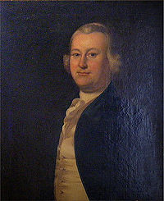
Birth: Feb 5, 1725 (Barnstable, MA)
Death: May 23, 1783 (Andover, MA)
(death, stuck by lightning)
Marriage: Ruth Cunningham (1755)
Birth: - (-)
Death: Nov 15, 1789 (-)
Children:
James: (1756-1777)
(died aboard a British prison ship)
Elizabeth: (-)
(married British officer & moved to England)
Mary: (-)
(married son of U.S. General Benjamin Lincoln)

- Leader of the Sons of Liberty
- Attorney
- Mentor of John Hancock and Samuel Adams
- 1743 graduate of Harvard College

http://freepages.family.rootsweb.ancestry.com/~carrollrogers/wc24/wc24_497.htm

http://en.wikipedia.org/wiki/James_Otis,_Jr.

http://www.famousamericans.net/jamesotis/
Mr. Otis seems always to have lived happily with his wife, but she failed to sympathize with him in his political career, and remained herself a stanch loyalist until her death, 15 November, 1789

http://www.wallbuilders.com/LIBissuesArticles.asp?id=8755
The Founding Fathers on Jesus, Christianity and the Bible

Has [government] any solid foundation? Any chief cornerstone?... I think it has an everlasting foundation in the unchangeable will of God… The sum of my argument is that civil government is of God.
(James Otis, The Rights of the British Colonies Asserted and Proved (London: J. Williams and J. Almon, 1766), pp. 11, 98.)

