John Morton
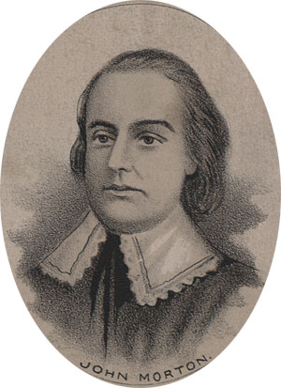
Birth: 1724 (Chester Co. PA)
Death: Apr 1, 1777 (-)
Marriage: Ann Justis (1744)
Birth: July 2, 1732 (New Castle Co, DE)
Death: abt 1800 (-)
Children:
Aaron: (1745 -)
Sketchley: (1747 -)
John: (1749 -)
Jacob: (bef. 1953 -)
Mary: (6/17/1754 -)
Sarah: (1756 -)
Lydia: (1760 -)
Ann: (1764 -)
Elizabeth: (1766 - 1830)

- Judge
- Legislator
- Signer of the Declaration of Independence (1776)

http://en.wikipedia.org/wiki/John_Morton_(politician)

http://www.ushistory.org/Declaration/signers/morton.htm

http://www.wallbuilders.com/LIBissuesArticles.asp?id=78
The Founders as Christians
With an awful reverence to the great Almighty God, Creator of all mankind, I, John Morton . . . being sick and weak in body but of sound mind and memory-thanks be given to Almighty God for the same, for all His mercies and favors-and considering the certainty of death and the uncertainty of the times thereof, do, for the settling of such temporal estate as it hath pleased God to bless me with in this life . . .
(From his last will and testament, attested January 28, 1777.)

The Lives of the Signers of the Declaration of Independence
By Rev. Charles A Goodrich - R.G. H. Huntington – Hartford 1842
(Page 284)
