Rev. Jedidiah Morse
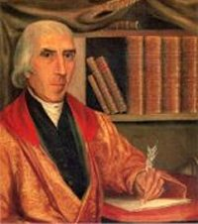
Birth: July 23, 1761 (Woodstock, CT)
Death: June 9, 1826 (New Haven, CT)
Marriage: Elizabeth Ann Finley Breese (-)
Birth: 1761 (-)
Death: May 28, 1828(New Haven, CT)
Children:
Samuel Finley Breese.: (1791-Apr 2, 1872)

- Graduated from Yale University (1783)
- Historian of the American Revolution
- Father of American Geography
- Documented condition of Indian Affairs

http://www.famousamericans.net/jedidiahmorse/

http://genealogy.henny-savenije.pe.kr/tng/register.php?personID=I192393&tree=savenije&generations=

http://www.wallbuilders.com/LIBissuesArticles.asp?id=8755
The Founding Fathers on Jesus, Christianity and the Bible

To the kindly influence of Christianity we owe that degree of civil freedom and political and social happiness which mankind now enjoys. All efforts made to destroy the foundations of our Holy Religion ultimately tend to the subversion also of our political freedom and happiness. In proportion as the genuine effects of Christianity are diminished in any nation… in the same proportion will the people of that nation recede from the blessings of genuine freedom… Whenever the pillars of Christianity shall be overthrown, our present republican forms of government – and all the blessings which flow from them – must fall with them.
(Jedidiah Morse, A Sermon, Exhibiting the Present Dangers and Consequent Duties of the Citizens of the United States of America, Delivered at Charlestown, April 25, 1799, The Day of the National Fast (MA: Printed by Samuel Etheridge, 1799), p. 9.)

