Lewis Morris
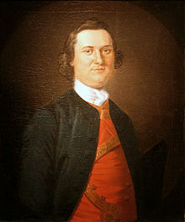
Birth: April 8, 1726 (Morrisania, Westchester Co. NY)
Death: Jan. 22, 1798 (Morrisania, Westchester Co. NY)
Marriage: Mary Walton (Sept 24, 1749)
Birth: May 14, 1727 (-)
Death: March 11, 1794 (-)
Children:
Catherine: (4 March 1751-22 November 1835)
Mary: (1752-5 July 1776)
Col. Lewis V.: (1754-22 November 1824
Gen. Jacob: (28 December 1755-10 January 1844)
Sarah: (born 1757- died young)
Lt. William Walton: (1760-5 April 1832)
Helena Magdalena: (1762-6 October 1840)
James: (1764-1 Sept 1827)
Capt. Staats: (1765-1826.
Capt. Richard Valentine: (8 March 1768-13 May 1815)

- Graduate Yale college
- Signer of the Declaration of Independence
- brother of Governeur Morris

http://en.wikipedia.org/wiki/Lewis_Morris
buried in the family vault beneath St. Anne's Episcopal Church in the Bronx.

The Lives of the Signers of the Declaration of Independence
By Rev. Charles A Goodrich - R.G. H. Huntington – Hartford 1842
(Page 199)

