Gouverneur Morris
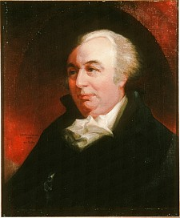
Birth: Jan. 31, 1752 (Morrisania, Westchester Co. NY)
Death: Nov. 1816 (Morrisania, Westchester Co. NY)
Marriage: Anne Cary Randolph (1809)
“Nancy”
Birth: Sept 15, 1774 (Goodland Co. VA)
Death: May 28, 1837 (NY)
Children:
Gouverneur Jr.: (2/9/1813 - )

- Revolutionary Officer
- Member of the Continental Congress
- Signer of the Constitution
- Penman of the Constitution
- U.S.Senator

http://www.history.army.mil/books/revwar/ss/morrisg.htm

http://colonialhall.com/morrisg/morrisg.php

http://www.wallbuilders.com/LIBissuesArticles.asp?id=8755
The Founding Fathers on Jesus, Christianity and the Bible

There must be religion. When that ligament is torn, society is disjointed and its members perish… [T]he most important of all lessons is the denunciation of ruin to every state that rejects the precepts of religion.
(Collections of the New York Historical Society for the Year 1821 (New York: E. Bliss and E. White, 1821), pp. 32, 34, from “An Inaugural Discourse Delivered Before the New York Historical Society by the Honorable Gouverneur Morris, (President,) 4th September, 1816.” )
Your good morals in the army give me sincere pleasure as it hath long been my fixed opinion that virtue and religion are the great sources of human happiness. More especially is it necessary in your profession firmly to rely upon the God of Battles for His guardianship and protection in the dreadful hour of trial. But of all these things you will and I hope in the merciful Lord.
(Letters of Delegates to Congress: February 1, 1778-May 31, 1778, Paul H. Smith, editor (Washington DC: Library of Congress, 1982), Vol. 9, pp. 729-730, Gouverneur Morris to General Anthony Wayne on May 21, 1778.)

