Rev. Jonathan Mayhew
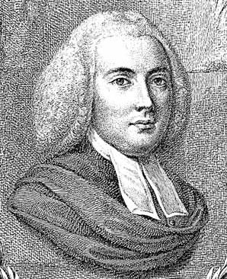
Birth: Oct 8, 1720 (Martha’s Vineyard, MA)
Death: July 9, 1766 (-)
Marriage- (-)
Birth: -(-)
Death: - (-)
Children:

- 1744 Graduated Harvard
- 1749 received degree DD from University of Aberdeen
- Pastor of the West Church in Boston

http://en.wikipedia.org/wiki/Jonathan_Mayhew

http://www.loc.gov/exhibits/religion/rel03.html
An eloquent proponent of the idea that civil and religious liberty was ordained by God, Jonathan Mayhew considered the Church of England as a dangerous, almost diabolical, enemyof the New England Way. The bishop's mitre with the snake emerging from it represented his view of the Anglican hierarchy.
Jonathan Mayhew delivered this sermon--one of the most influential in American history--on the anniversary of the execution of Charles I. In it, he explored the idea that Christians were obliged to suffer under an oppressive ruler, as some Anglicans argued. Mayhew asserted that resistance to a tyrant was a "glorious" Christian duty. In offering moral sanction for political and military resistance, Mayhew anticipated the position that most ministers took during the conflict with Britain. (after the 30th January 1749-50)

