Henry Marchant
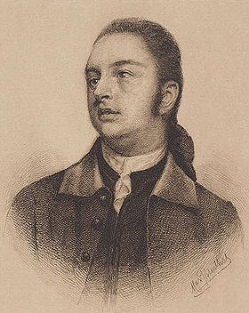
Birth: April 9, 1741 (Marthas Vineyard, MA)
Death: August 30, 1796 (Newport, RI)
Marriage- (-)
Birth: -(-)
Death: - (-)
Children:

- 1762 graduate Philadelphia College
- 1767 admitted to Bar RI
- 1777-9 Member of the Continental Congress
- Attorney General of RI
- 1790-96 Federal Judge RI district

http://virtualology.com/hallofusa/articlesofconfederation/HENRYMARCHANT.COM/

http://bioguide.congress.gov/scripts/biodisplay.pl?index=M000125

http://www.wallbuilders.com/LIBissuesArticles.asp?id=8755
The Founding Fathers on Jesus, Christianity and the Bible

And may God grant that His grace may really affect your heart with suitable impressions of His goodness. Remember that God made you, that God keeps you alive and preserves you from all harm, and gives you all the powers and the capacity whereby you are able to read of Him and of Jesus Christ, your Savior and Redeemer, and to do every other needful business of life. And while you look around you and see the great privileges and advantages you have above what other children have (of learning to read and write, of being taught the meaning of the great truths of the Bible), you must remember not to be proud on that account but to bless God and be thankful and endeavor in your turn to assist others with the knowledge you may gain.
(Letters of Delegates to Congress: May 1, 1777 - September 18, 1777, Paul H. Smith, editor (Washington DC: Library of Congress, 1981), Vol. 7, pp. 645-646, Henry Marchant to Sarah Marchant, his daughter, on September 9, 1777.)

