Rev. James Manning
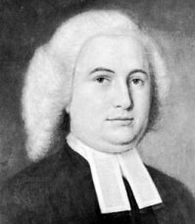
Birth: Nov 22, 1738 (Elizabethtown, NJ)
Death: July 29, 1791 (Providence, RI)
Marriage: Margaret Stites (Mar 22, 1763)
Birth: Oct 16, 1740 (Elizabethtown, NJ)
Death: Nov 9, 1815 (Providence, RI)
Children: (none)

- American Baptist minister
- Graduated Princeton University (1762)
- President and a founders of Brown University
- Delegate to Continental Congress from RI (1786)

http://en.wikipedia.org/wiki/James_Manning_(Minister)

http://www.public.asu.edu/~bgertz/family/d0012/g0000046.html#I2557

http://www.wallbuilders.com/LIBissuesArticles.asp?id=8755
The Founding Fathers on Jesus, Christianity and the Bible

I rejoice that the religion of Jesus prevails in your parts; I can tell you the same agreeable news from this quarter. Yesterday I returned from Piscataway in East Jersey, where was held a Baptist annual meeting (I think the largest I ever saw) but much more remarkable still for the Divine influences which God was pleased to grant. Fifteen were baptized; a number during the three days professed to experience a change of heart. Christians were remarkably quickened; multitudes appeared.
(Letters of Delegates to Congress: November 7, 1785-November 5, 1786, Paul H. Smith, editor (Washington DC: Library of Congress, 1995), Vol. 23, p. 337, James Manning to Robert Carter on June 7, 1786.)

