Philip Livingston
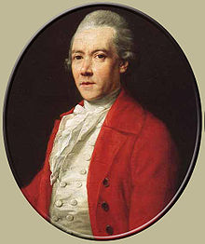
Birth: Jan. 15, 1716 (Albany, NY)
Death: June 12, 1778 (York, PA)
Marriage: Christiana Ten Broeck (1740)
Birth: Dec. 30, 1718 (Albany, NY)
Death: - (-)
Children:
Philip Philip: (5/28/1741 – 11/2/1787)
Richard: ( - )
Catharine: (8/25/1745 – 4/17/1810)
Margaret: (1747 – 1/17/1830)
Peter Van Brugh: (1751 -)
Sarah: (12/7/1752 – 12/7/1814)
Abraham: (1754 -)
Alida: (1757 -)
Henry Philip: (1760 -)

- Graduate Yale (1737)
- Signer of the Declaration of Independence
- State senator NY
- Continental congress (1778)

http://en.wikipedia.org/wiki/Philip_Livingston

http://www.ushistory.org/declaration/signers/livingston_p.htm

http://www.iment.com/maida/familytree/henry/bios/signerphiliplivingston.htm

The Lives of the Signers of the Declaration of Independence
By Rev. Charles A Goodrich - R.G. H. Huntington – Hartford 1842
(Page 192)
