Henry Laurens
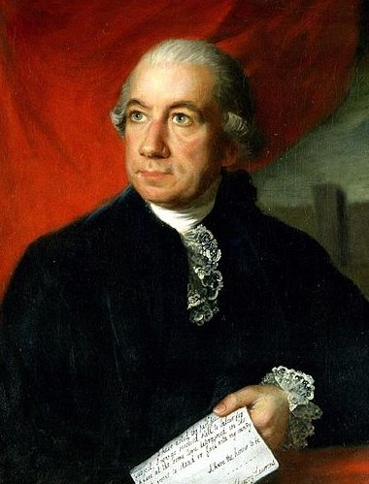
Birth: March 6, 1724 (Charleston, SC)
Death: December 8, 1792 (-)
Marriage: Eleanor Ball (-)
Birth: - (-)
Death: - (-)
Children: (They had 12 children only 4 reached adulthood)
- John served as a military aide to General Washington and was killed in the Revolutionary War. During the war, John proposed a plan under which a small number of slaves would be enlisted in the American forces and eventually granted their freedom. In a private letter, Henry gently sought to persuade John that this plan was impractical.
- Martha married David Ramsay, a physician, historian, and South Carolina Congressman.
- Henry Jr. married Eliza, the daughter of John Rutledge, and inherited his father's estate.
- Mary married Charles Pinckney and died in childbirth soon afterwards.

- President of Congress
- Delegate to the Constitutional Convention

http://en.wikipedia.org/wiki/Henry_Laurens

http://bioguide.congress.gov/scripts/biodisplay.pl?index=L000121

http://www.henrylaurens.com/
Through his London contacts, Laurens entered into the slave trade with the Grant, Oswald & Company who controlled 18th century British slave castle in the Republic of Sierra Leone, West Africa known as Bunce Castle. Laurens contracted to receive slaves from Serra Leone, catalogue and marketed the human product conducting public auctions in Charles Town. Laurens also engaged in the import and export of many other products but his 10% commission from the slave auctions proved to be his major source of his income.

http://www.wallbuilders.com/LIBissuesArticles.asp?id=121
The Founders and Public Religious Expressions

I had the honor of being one among many who framed that Constitution. . . . In order effectually to accomplish these great ends, it is incumbent upon us to begin wisely and to proceed in the fear of God; . . . and it is especially the duty of those who bear rule to promote and encourage piety [respect for God].
(Henry Laurens, The Papers of Henry Laurens, George C. Rogers Jr. and David R. Chestnutt, editors (Columbia: University of South Carolina Press, 1988), Vol. XI, p. 200, in a letter to Oliver Hart and Elharon Winchester on March 30, 1776.)

