John Langdon
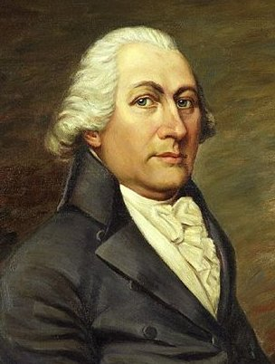
Birth: June 26, 1741 (Portsmouth, NH)
Death: September 18, 1819 (Portsmouth, NH)
Marriage- (-)
Birth: -(-)
Death: - (-)
Children:

- Served in Revolutionary Army
- 1785-6, 1788-9, 1805-6, 1810-12 Governor NH
- 1788 Signer of the Constitution
- 1789-1801 U.S. Senate representing NH

http://en.wikipedia.org/wiki/John_Langdon

http://www.history.army.mil/books/RevWar/ss/langdon.htm

http://bioguide.congress.gov/scripts/biodisplay.pl?index=L000067

http://www.wallbuilders.com/LIBissuesArticles.asp?id=78
The Founders as Christians

In the name of God, Amen. I, John Langdon, . . . considering the uncertainty of life and that it is appointed unto all men once to die [Hebrews 9:27], do make, ordain and publish this my last will and testament in manner following, that is to say-First: I commend my soul to the infinite mercies of God in Christ Jesus, the beloved Son of the Father, who died and rose again that He might be the Lord of the dead and of the living . . . professing to believe and hope in the joyful Scripture doctrine of a resurrection to eternal life . . .
(Will of John Langdon)

