Henry Knox
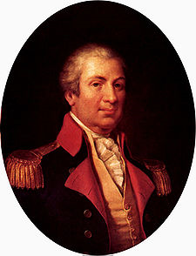
Birth: July 25, 1750 (Boston, MA)
Death: Oct. 10, 1806 (Thomaston, ME)
Marriage: Lucy Flucker (June 16, 1774)
Birth: Aug. 2, 1756 (Boston, MA)
Death: June 20, 1824 (Thomaston, ME)
Children:
Caroline Flucker: (-)
Lucy Flucker: (1774 - 10/12/1854)
(May have other children)

- Revolutionary War General
- Secretary of War (1785 – 1794)

http://en.wikipedia.org/wiki/Henry_Knox

http://www.history.army.mil/books/sw-sa/Knox.htm

http://www.wallbuilders.com/LIBissuesArticles.asp?id=78
The Founders as Christians

First, I think it proper to express my unshaken opinion of the immortality of my soul or mind; and to dedicate and devote the same to the supreme head of the Universe – to that great and tremendous Jehovah, – Who created the universal frame of nature, worlds, and systems in number infinite . . . To this awfully sublime Being do I resign my spirit with unlimited confidence of His mercy and protection . . .
(Will of Henry Knox)

