James Kent
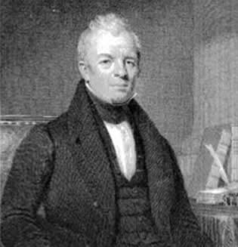
Birth: July 31, 1763 (Fredericksburg, NY)
Death: Dec. 12, 1847 (New York City, NY)
Marriage: Elizabeth Bailey (1785)
Birth: Sep. 10, 1768 (-)
Death: June 19, 1851 (-)
Children:
Elizabeth: (3/25/1791 - 5/26/1793)
Elizabeth: (2/26/1796 - )
William: (10/2/1802 - 1/4/1861)
Mary: (5/19/1807 - )

- Judge
- Law Professor
- Father of American Jurispudence

http://en.wikipedia.org/wiki/James_Kent

http://www.iment.com/maida/familytree/henry/bios/jameskent.htm

http://books.google.com/books?id=XSPAAtr1y04C&printsec=frontcover&dq=inauthor:James+inauthor:Kent&cd=2#v=onepage&q=&f=false
Memoirs and Letters of James Kent by William Kent

http://www.wallbuilders.com/LIBissuesArticles.asp?id=8755
The Founding Fathers on Jesus, Christianity and the Bible

My children, I wish to talk to you. During my early and middle life I was, perhaps, rather skeptical with regard to some of the truths of Christianity. Not that I did not have the utmost respect for religion and always read my Bible, but the doctrine of the atonement was one I never could understand, and I felt inclined to consider as impossible to be received in the way Divines taught it. I believe I was rather inclined to Unitarianism; but of late years my views have altered. I believe in the doctrines of the prayer books as I understand them, and hope to be saved through the merits of Jesus Christ. . . . My object in telling you this is that if anything happens to me, you might know, and perhaps it would console you to remember, that on this point my mind is clear: I rest my hopes of salvation on the Lord Jesus Christ.
(William Kent, Memoirs and Letters of James Kent, (Boston: Little, Brown, and Company, 1898), pp. 276-277.)

