Daniel of St. Thomas Jenifer
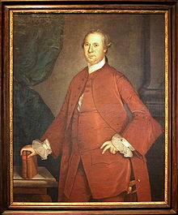
Birth: 1723 (Charles County, MD)
Death: Nov. 16, 1790 (-)
Marriage: (never married)

- Continental congress (1778 – 1782)
- MD council of safety (1775 -1777)
- President MD state senate (1777 – 1780)
- Signer of the Constitution

http://en.wikipedia.org/wiki/Daniel_of_St._Thomas_Jenifer

http://www.let.rug.nl/usa/B/jenifer/jenifer.htm

http://restart.typepad.com/my_weblog/2008/11/daily-constitution---signer-of-the-constitution---daniel-of-st-thomas-jennifer.html

http://www.wallbuilders.com/LIBissuesArticles.asp?id=78
The Founders as Christians

In the name of God, Amen. I, Daniel of Saint Thomas Jenifer . . . of dispossing mind and memory, commend my soul to my blessed Redeemer. . .
(Will of Daniel St. Thomas Jenifer)

