Andrew Jackson
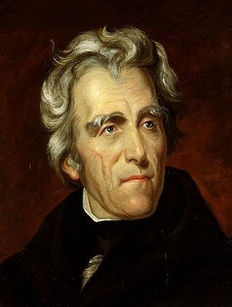
Birth: March 15, 1767 (-)
Death: June 8, 1845 (Nashville, TN)
Marriage: Rachel Donelson Robards (-)
Birth: -(-)
Death: - (-)
Marriage: Emily Donelson (-)
Birth: -(-)
Death: - (-)
Marriage: Sarah Yorke (-)
Birth: -(-)
Death: - (-)
Children: (All Adopted)
Andrew Jackson Jr.
Lyncoya Jackson
John Samuel Donelson
Daniel Smith Donelson
Andrew Jackson Donelson
Andrew Jackson Hutchins
Caroline Butler
Eliza Butler
Edward Butler
Anthony Butler

- 1796-1797 U.S. House of Representatives from TN
- 1797-1798 U.S. Senate from TN
- 1821 Territorial Governor FL
- 1829-1837 7th U.S. President

http://hockingcountyndp.org/vsItemDisplay.dsp&objectID=E36F8D93-3E4E-4406-AA3B52877289919B&method=display

Providence has showered on this favored land blessings without number and has chosen you as the guardians of freedom, to preserve it for the benefit of the human race. May He who holds in His hands the destinies of nations, make you worthy of the favors He has bestowed, and enable you, with pure hearts and hands and sleepless vigilance, to guard and defend to the end of time, the great charge He has committed to your keeping.
(Andrew Jackson, March 4, 1837 in his Farewell Address)

