John Hart
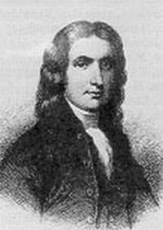
Birth: Nov. 5, 1711 (Stonington, CT)
Death: May 11, 1779 (-)
Marriage: Deborah Scudder (1739)
Birth: - (-)
Death: Nov 7, 1776 (Hopewell, NJ)
Children:
Sarah: (Oct 16, 1741-1800)
Jesse: (Sep 19, 1742-1815)
Martha: (Apr 10, 1746-1815)
Nathaniel: (Oct 29, 1747-18250
John: (Oct 29, 1748-Mar 22, 1790)
Susannah: (1750-1832)
Mary Mildred: (Apr 7, 1752-1782)
Abigail: (Feb 10, 1754-1833)
Edward: (Dec 20, 1755-Oct 5, 1812)
Scudder: (Dec 30, 1757-1758)
Daniel: (Aug 13, 1762-Sept 12, 1848)
Deborah: (1765-1848)

- Judge
- Legislator
- Signer of the Declaration of Independence (1776)

http://damon-family.org/genealogy/p57.htm

http://www.scratchinpost.net/barefootbob//johnhart.html
Although a Presbyterian, in 1747 he donated land to the Baptist for a church building. This later became known as the “Baptist Meeting House”.

Born in CT, came to NJ at an early age.

http://www.wallbuilders.com/LIBissuesArticles.asp?id=8755
The Founding Fathers on Jesus, Christianity and the Bible

[T]hanks be given unto Almighty God therefore, and knowing that it is appointed for all men once to die and after that the judgment [Hebrews 9:27] . . . principally, I give and recommend my soul into the hands of Almighty God who gave it and my body to the earth to be buried in a decent and Christian like manner . . . to receive the same again at the general resurrection by the mighty power of God.
(From his last will and testament, attested April 16, 1779.)

The Lives of the Signers of the Declaration of Independence
By Rev. Charles A Goodrich - R.G. H. Huntington – Hartford 1842
(Page 229)
