John Hancock
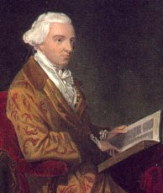
Birth: Jan 23, 1737 (Quincy MA)
Death: Oct 8, 1793 (Quincy, MA)
Marriage: Dorothy Quincy (Aug 28, 1775)
Birth: May 10, 1747(Boston, MA)
Death: Feb 3, 1830(Boston, MA)
Children:
Lydia: (1776- )
John George Washington: (1778- )
Nancy: (Feb 17, 1783- )

- Graduated Boston Latin School (1750)
- Graduated Harvard University (1754)
- President of MA Provincial Congress (1774-1775)
- President of the Continental Congress (1775-1777)
- Signer of the Declaration of Independence (1776)
- Revolutionary General
- Governor of MA (1780-1785 & 1787-1793)

http://en.wikipedia.org/wiki/John_Hancock

http://freepages.genealogy.rootsweb.ancestry.com/~dantrogers/pafg1742.htm

http://www.wallbuilders.com/LIBissuesArticles.asp?id=8755
The Founding Fathers on Jesus, Christianity and the Bible

Sensible of the importance of Christian piety and virtue to the order and happiness of a state, I cannot but earnestly commend to you every measure for their support and encouragement.³⁸
(Independent Chronicle (Boston), November 2, 1780, last page; see also Abram English Brown, John Hancock, His Book (Boston: Lee and Shepard, 1898), p. 269.)
He called on the entire state to pray “that universal happiness may be established in the world [and] that all may bow to the scepter of our Lord Jesus Christ, and the whole earth be filled with His glory.”
(John Hancock, A Proclamation For a Day of Public Thanksgiving 1791, given as Governor of the Commonwealth of Massachusetts, from an original broadside in our possession.)

He also called on the State of Massachusetts to pray . . .
- that all nations may bow to the scepter of our Lord and Savior Jesus Christ and that the whole earth may be filled with his glory.
(John Hancock, Proclamation for a Day of Public Thanksgiving, October 28, 1784, from a proclamation in Wallbuilders possession, Evans #18593.)

- that the spiritual kingdom of our Lord and Savior Jesus Christ may be continually increasing until the whole earth shall be filled with His glory.
(John Hancock, Proclamation for a Day of Public Thanksgiving, October 29, 1788, from a proclamation in Wallbuilders possession, Evans #21237.)

- to confess their sins and to implore forgiveness of God through the merits of the Savior of the World.
(John Hancock, Proclamation For a Day of Fasting and Prayer, March 16, 1789, from a proclamation in Wallbuilders possession, Evans #21946.)

- to cause the benign religion of our Lord and Savior Jesus Christ to be known, understood, and practiced among all the inhabitants of the earth.
(John Hancock, Proclamation for a Day of Thanksgiving and Praise, September 16, 1790, from an original broadside in Wallbuilders possession.)

- to confess their sins before God and implore His forgiveness through the merits and mediation of Jesus Christ, our Lord and Savior.
(John Hancock, Proclamation for a Day of Fasting and Prayer, February 11, 1791, from a proclamation in Wallbuilders possession, Evans #23549.)

- that He would finally overrule all events to the advancement of the Redeemer’s kingdom and the establishment of universal peace and good will among men.
(John Hancock, Proclamation for a Day of Fasting, Prayer and Humiliation, February 24, 1792, from a proclamation in Wallbuilders possession, Evans #24519.)

- that the kingdom of our Lord and Savior Jesus Christ may be established in peace and righteousness among all the nations of the earth.
(John Hancock, Proclamation for a Day of Public Thanksgiving, October 25, 1792, from an original broadside in Wallbuilders possession.)

- that with true contrition of heart we may confess our sins, resolve to forsake them, and implore the Divine forgiveness, through the merits and mediation of Jesus Christ, our Savior. . . . And finally to overrule all the commotions in the world to the spreading the true religion of our Lord Jesus Christ in its purity and power among all the people of the earth.
(John Hancock, Proclamation for Day of Public Fasting, Humiliation and Prayer, March 4, 1793, from a broadside in Wallbuilders possession.)

http://www.wallbuilders.com/LIBissuesArticles.asp?id=121
The Founders and Public Religious Expressions

Sensible of the importance of Christian piety and virtue to the order and happiness of a state, I cannot but earnestly commend to you every measure for their support and encouragement. . . . [T]he very existence of the republics . . . depend much upon the public institutions of religion.
(Independent Chronicle (Boston), November 2, 1780, last page; see also Abram English Brown, John Hancock, His Book (Boston: Lee and Shepard, 1898), p. 269.)

http://www.wallbuilders.com/LIBissuesArticles.asp?id=78
The Founders as Christians
I John Hancock, . . . being advanced in years and being of perfect mind and memory-thanks be given to God-therefore calling to mind the mortality of my body and knowing it is appointed for all men once to die [Hebrews 9:27], do make and ordain this my last will and testament…Principally and first of all, I give and recommend my soul into the hands of God that gave it: and my body I recommend to the earth . . . nothing doubting but at the general resurrection I shall receive the same again by the mercy and power of God. . .
(Will of John Hancock)

http://www.eadshome.com/Jefferson.htm
“We recognize no Sovereign but God, and no King but Jesus!”
[April 18, 1775, on the eve of the Revolutionary War after a British major ordered John Adams, John Hancock, and those with them to disperse in “the name of George the Sovereign King of England." ]

The Lives of the Signers of the Declaration of Independence
By Rev. Charles A Goodrich - R.G. H. Huntington – Hartford 1842
(Page 74)
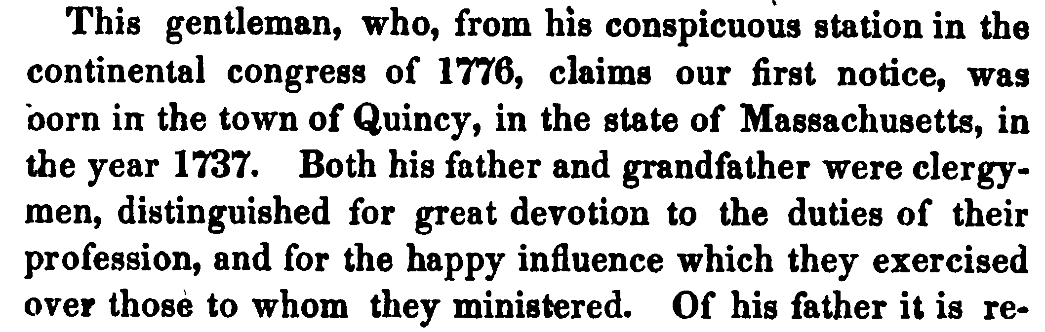
(Page 81)
At that time, the Americans army was besieging Boston, to expel the British, who held possession of the town. To accomplish this object, the entire destruction of the city was proposed by the American officers. By the execution of such a plan, the whole fortune of Mr. Hancock would have been sacrificed. Yet he immediately acceded to the measure, declaring his readiness to surrender his all, whenever the liberties of his country should require it.

