William Ellery
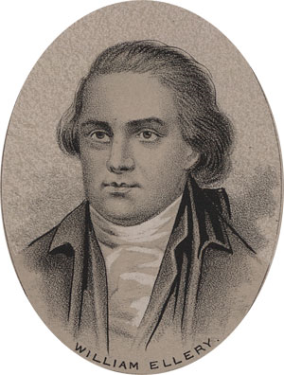
Birth: Dec. 22, 1727 (Newport, RI)
Death: Feb. 15, 1820 (-)
Marriage: Ann Remington (-)
Birth: 1725 (-)
Death: Sep. 9, 1764 (-)
Children:
Elizabeth: (8/13/1751 – 1807)
Lucy: (9/21/1752 -)
Ann: (4/47/1755 – 9/21/1834)
William: (3/2/1757 – young)
Almy: (2/14/1759 – 12/25/1839)
William: (10/6/1761 – 5/9/1836)
Edmund: (11/2/1763 – 3/12/1847)

Marriage: Abigail Cary (June 28, 1767)
Birth: Nov. 12, 1742(-)
Death: July 27, 1793 (-)
Children:
Abigail: (3/28/1768 – 10/14/1768)
Nathaniel: (5/13/1769 – 10/18/1839)
John Wilkins: (5/18/1770 – 10/4/1778)
Ruth Champlin: (9/4/1773 -)
Susanna Kent: (6/11/1775 – 4/14/1828)
Philadelphia: (11/5/1776 – 4/24/1856)
Henrietta L.: (abt 1780 – 1807)
Mehitable: (1/4/1784 – 8/11/1832)
George Wanton: (12/24/1789 – 1/26/1867)

- Signer of the Declaration of Independence
- Continental Congress (1776-1785)
- Supreme Court of RI (1778-?)

http://www.ushistory.org/declaration/signers/ellery.htm

http://virtualology.com/declarationofindependence/WilliamEllery.com/

http://colonialhall.com/ellery/ellery.php

The Lives of the Signers of the Declaration of Independence
By Rev. Charles A Goodrich - R.G. H. Huntington – Hartford 1842
(Page 157)

