Gabriel Duvall
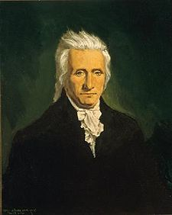

Birth: Dec 6, 1752 (Prince Georges Co. MD)
Death: Mar 6, 1844 (Marietta, MD)
Marriage: Mary Bryce (Jul 24, 1787)
Birth: 1761 (-)
Death: Mar 24, 1790 (-)
Children:
Edmund Bryce: (Jan 25, 1790-Feb 5, 1831)

Marriage: Jane Gibbon (May 5, 1795)
Birth: 1757 (Philadelphia, PA)
Death: Apr 17, 1834 (-)
Children:

- Soldier
- Judge
- Admitted to MD Bar (1778)
- Delegate to the Constitutional Convention
- Comptroller of the U.S. Treasury (1802-1811)
- U.S. Supreme Court Justice (1811-1834)
- U.S. house of Representatives: (1794-1796)

http://en.wikipedia.org/wiki/Gabriel_Duvall

http://www.pitard.net/genealogy/getperson.php?personID=I12144&tree=Pitard

http://wc.rootsweb.ancestry.com/cgi-bin/igm.cgi?op=GET&db=dowfam3&id=I137792

http://www.wallbuilders.com/LIBissuesArticles.asp?id=8755
The Founding Fathers on Jesus, Christianity and the Bible

I resign my soul into the hands of the Almighty Who gave it, in humble hopes of His mercy through our Savior Jesus Christ.
(From his last will and testament, attested on September 21, 1840.)

