William Cushing
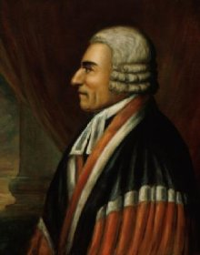
Birth: March 1, 1732 (Scituate, MA)
Death: September 13, 1810 (Scituate, MA)
Marriage: Hannah Phillips (1774)
Birth: - (-)
Death: - (-)
Children:
(None)

- 1751 graduate, Harvard College
- 1753 honorary masters degree of arts, Yale University
- 1755 Bar of Boston
- 1785 honorary doctor of law, Harvard University
- First Associate Justice Appointed by George Washington to the Supreme Court
- 1789-1810 Supreme Court U.S. (21 years, longest of original appointees)

References:
http://www.michaelariens.com/ConLaw/justices/cushing.htm

http://law.jrank.org/pages/5936/Cushing-William.html

http://www.wallbuilders.com/LIBissuesArticles.asp?id=78
The Founders as Christians

Sensible of my mortality, but being of sound mind, after recommending my soul to Almighty God through the merits of my Redeemer and my body to the earth . . .
(Will of William Cushing)

