Grover Cleveland
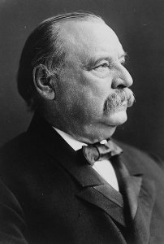
full name: Stephen Grover Cleveland
Birth: March 18, 1837 (Caldwell, NJ)
Death: June 24, 1908 (Princeton, NJ)
Marriage: Frances Folsom (June 2, 1886)
Birth: July 21, 1864 (Buffalo, NY)
Death: October 29, 1947 (Baltimore, MD)
Children:
Ruth: (1891-1904)
Esther: (1893-1890)
Marion: (1895-1977)
Richard Folsom: (1897-1974)
Francis Grover: (1903-1995)

- 1882 Mayor Buffalo, NY
- 1883-1885 Governor NY
- 1885-1889 22nd President U.S.
- 1893-1897 24th President U.S.
- Only Presidential marriage in the White House
- France at age 21, youngest First Lady

http://en.wikipedia.org/wiki/Grover_Cleveland
Parents were Richard Falley Cleveland and Ann Neal Cleveland. Cleveland's father was a Presbyterian minister,

http://hockingcountyndp.org/vsItemDisplay.dsp&objectID=E36F8D93-3E4E-4406-AA3B52877289919B&method=display

Above all, I know there is a Supreme Being who rules the affairs of men and whose goodness and mercy have always followed the American people, and I know He will not turn from us now if we humbly and reverently seek His powerful aid.
(Grover Cleveland, March 4, 1893)

