Jacob Broom
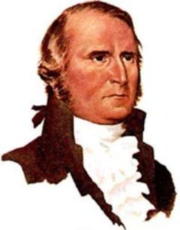
Birth: Oct 17, 1752 (Wilmington, DE)
Death: Apr 1810 (-)
Marriage: Rachel Pierce (Dec 14, 1773)
Birth: Feb 17, 1752 (Wilmington, DE)
Death: - (-)
Children:
Ann (Nancy): (Aug 22, 1775-1824)
James Madison: (1776-Jan 15, 1850)
Elizabeth: (Sep 20, 1777-1807)
Esther Willis: (1779-)
Rachel: (1781-)
Sarah: (1783-)
Jacob Pierce: (June 7, 1786-1864)
Rachel Maria: (July 20, 1788-1864)
Lavina Laurnia: (May 12, 1790-)
Nicholas Way: (July, 1793-)

- Legislator
- Signer of the Constitution

http://www.laughtergenealogy.com/bin/histprof/founders/const/broom.html

http://www.mccullough.nl/Jacob_Broom.htm

http://www.finlayfamily.org/genealogy/individual.php?pid=I1173&ged=test.ged

http://freepages.genealogy.rootsweb.ancestry.com/~lynnvr/Lyon01.htm

http://www.wallbuilders.com/LIBissuesArticles.asp?id=8755
The Founding Fathers on Jesus, Christianity and the Bible

A letter to his son, James, attending Princeton University:
I flatter myself you will be what I wish, but don’t be so much flatterer as to relax of your application – don’t forget to be a Christian. I have said much to you on this head, and I hope an indelible impression is made.
(Jacob Broom to his son, James, on February 24, 1794, written from Wilmington, Delaware, from an original letter in Wallbuilders possession.)

http://www.wallbuilders.com/LIBissuesArticles.asp?id=52
(Full text of letter)

