Gunning Bedford
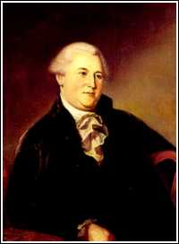

Birth: Apr 13, 1747 (Philadelphia, PA)
Death: Mar 30, 1812 (Wilmington, DE)
Marriage: Jane B. Parker (-)
Birth: -(-)
Death: - (-)
Children: (at least 1 daughter)

- Military Officer
- Member of Continental Congress (1787)
- Signer of the Constitution
- Federal Judge (1789-)
- Graduate Princeton University (1771)

http://en.wikipedia.org/wiki/Gunning_Bedford,_Jr.

http://www.let.rug.nl/usa/B/bedford/bedford.htm

http://www.wallbuilders.com/LIBissuesArticles.asp?id=8755
The Founding Fathers on Jesus, Christianity and the Bible

To the triune God – the Father, the Son, and the Holy Ghost – be ascribed all honor and dominion, forevermore – Amen.
(Gunning Bedford, Funeral Oration Upon the Death of General George Washington (Wilmington: James Wilson, 1800), p. 18, Evans #36922.)

