Abraham Baldwin
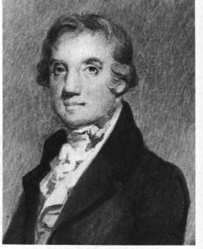
Birth: Nov. 22, 1754 (North Guilford, CT)
Death: March 4, 1807 (Washington D.C.)
Marriage- (-)
Birth: -(-)
Death: - (-)
Children:

- 1772 graduate Yale University
- 1775 licensed minister
- 1777-1783 Chaplin 2nd CT Brigade Revolutionary Army
- 1785-1788 Continental Congress
- Signer of the Constitution
- Framer of the Bill of Rights
- 1785 founder of University of Georgia
- 1789-1799 U.S. Congress
- 1786-1801 president of University of Georgia
- 1799-1807 U.S. Senate representing Georgia

http://bioguide.congress.gov/scripts/biodisplay.pl?index=B000084

http://www.wallbuilders.com/LIBissuesArticles.asp?id=121
The Founders and Public Religious Expressions

[A] free government. . . . can only be happy when the public principle and opinions are properly directed. . . . by religion and education. It should therefore be among the first objects of those who wish well to the national prosperity to encourage and support the principles of religion and morality.
(Charles C. Jones, Biographical Sketches of the Delegates from Georgia to the Continental Congress (Boston: Houghton, Mifflin, and Company, 1891), pp. 6-7.)

